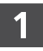 Maria wants to find 0.2 × 0.6
What model should Maria use to find the product? (Hint- 0.2 of 0.6)
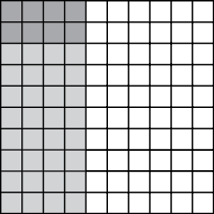
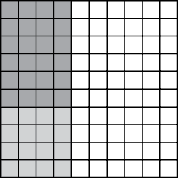
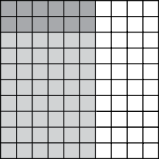
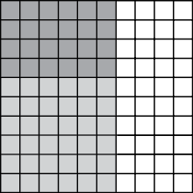
What is the product?
0.2 × 0.6 = ______
 During a track meet, Calvin drinks 0.6 liter of water. Melinda drinks 0.8 times as much water as Calvin during the track meet. How much water does Melinda drink during the track meet?
(Hint- 0.8 of 0.6)
______ liter(s)
 Place an X in the table to show if each sentence is true or false.
(Hint- Solve each one)
 | True | False
1.3 x 2.1 = 2.73
4.8 x 0.4 = 12.2
0.08 x 0.7 = 5.6
0.21 x 1.8 = 0.378
 Bruce is getting materials for a chemistry experiment. He gets a container that has
0.25 liter of a liquid in it. Bruce needs to use 0.4 of this liquid for the experiment. How much liquid will
Bruce use? (Hint- Think 0.4 of 0.25)
100 liters
1 liter
0.1 liter
0.001 liter
 A builder buys 16.1 acres of land to develop a new set of walking trails and baseball fields. (An acre is a measure of land.)
Part A
The builder will use 0.25 of the 16.1 acres for baseball fields. How many acres will be used for the baseball?
______ acres
Part B
The builder buys a second property which is 0.41 times as large as the 16.1 acres. How big is the second property?
______ acres
 Which equation is shown by the model?
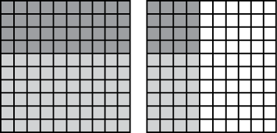
4 groups of 1.4 = 5.6
0.4 of 1.14 = 0.056
0.4 of 0.14 = 0.056
0.04 of 0.14 = 0.0056
 Make the equation true (properties)
0.3 × 1.8 × 0.2 = (0.3 × _____) × 1.8
 Mr. O’Brien is paid $9.30 per hour for the first 40 hours he works in a week. He is paid 1.5 times $9.30 for each hour after that. Last week, Mr. O’Brien worked 44 hours. How much did Mr. O’Brien earn last week?
_____________________

 Gia multiplies 2.3 by 1.65 To what decimal place will her answer go?
thousandths
hundredths
tenths
ones
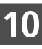 To solve 0.2 × 0.06 Pilar multiplies whole numbers. She writes
2 × 6 = 12. Which answer shows where Pilar should place the decimal?
12.00
0.012
0.12
1.20

